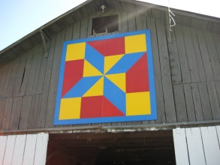
Quilt-Topia Barn Quilt Challenge
This geometric-based square is the perfect opportunity to funnel your quilting creativity into a show-stopping square that will stop Fairgoers in their tracks. The winning quilt block will be reproduced by painting on sign board and proudly displayed on one of the buildings at the Washburn County Fair Grounds.
Barn quilts were originally conceived to encourage economic development by promoting ag-tourism and local businesses while bringing travelers to rural areas. While quilts are usually made up of a series of squares of the same pattern placed together, a barn quilt is always a single square.
Prize Money
1st place - $30.00 ~and~ reproduced into a barn quilt at the Washburn County Fair.
2nd Place – 20.00
3rd Place – 10.00
People’s Choice Award- Ribbon only
Contest details
*The theme for the 2019 &2020 fair is “How Sweet it is at the Washburn County Fair.”
(Use your imagination and go wild.)
*Only one square, with backing, batting and bound should be submitted (must be square).
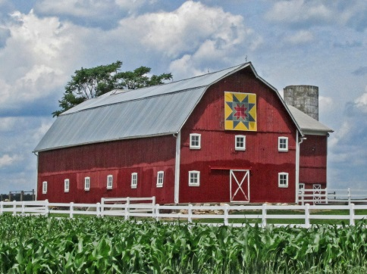
* The finished square should be no smaller than 12”x12” and no larger than 16”x16”.
*The finished square can be quilted or tied.
*The finished square should be pieced, not appliqued.
*The finished square should be made with solid fabrics (no prints).
*The finished square can have no more than six different colors.
*The finished square can be hand or machine sewn.
*The finished square must not have curves in the design.
*Entry must be completed by the exhibitor.
*Team or group entries will be allowed but members of team or group may not enter as an
Individual.
*One entry per team or individual
* Entry must be family-friendly.
* All entries must be submitted by June 13, 2020.
* All entries must be mailed to Linda Degner W7402 Fox Trail Road Shell Lake, Wi 54871 or dropped off at Bashaw Valley Farm and Greenhouse
*Please include Name, address, phone number and email address on a sheet of paper with your entry. Place quilt block and info paper inside a large plastic bags
* Awards will be announced via the local papers and facebook. Prizes will be mailed.
If you have questions or need more information please call Linda at (715) 645-2078
Quilt-Topia Barn Quilt Challenge Entry Form 2019-20

Name Individual:_________________________________________________________
Team Members:_________________________________________________________
_______________________________________________________________________
Address:________________________________________________________________
City:__________________________State:_______________Zip Code:______________
Phone number: ( )_______________________
Email address:____________________________________________________
Size of Quilt Block:_________________________________________________
Colors used:______________________________________________________

Quilt-Topia Barn Quilt Challenge Entry Form 2019-20

Name Individual:_________________________________________________________
Team Members:_________________________________________________________
_______________________________________________________________________
Address:________________________________________________________________
City:__________________________State:_______________Zip Code:______________
Phone number: ( )_______________________
Email address:____________________________________________________
Size of Quilt Block:_________________________________________________
Colors used:______________________________________________________

